Knowledge Entity Modeler Report

Situation Model

**Published: 5/11/2020**

**By: Sottara, Davide**

Table of Contents

# Core Situation Model (SNOMED)

## Diagram

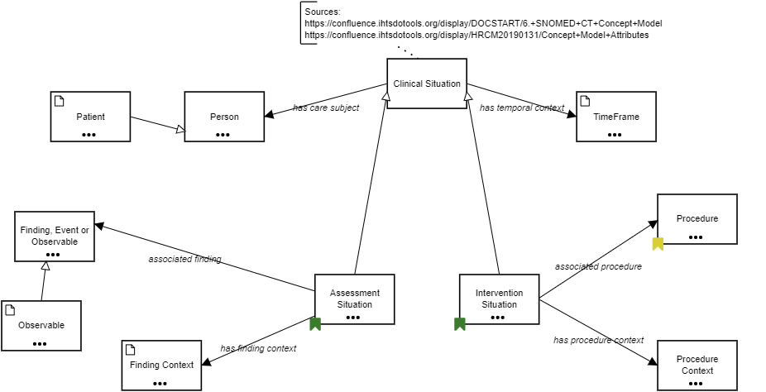

## Terms

**Clinical Situation**

**Relations**

* Assessment Situation *is a* Clinical Situation
* Intervention Situation *is a* Clinical Situation
* Clinical Situation *has care subject* Person
* Clinical Situation *has temporal context* TimeFrame

**Custom**

|  |  |
| --- | --- |
| SNOMED | http://snomed.info/id/243796009 |

**Patient**

**Data Type**

|  |  |
| --- | --- |
| Type | fhirPatient |

**Relations**

* Patient *is a* Person
* Current (Patient) Obs *has care subject* Patient

**Custom**

|  |  |
| --- | --- |
| SNOMED | http://snomed.info/id/125676002 |

**Person**

**Relations**

* Patient *is a* Person
* Subject of Record *is a* Person
* anf:Statement *anf:subjectOfInformation* Person
* Clinical Situation *has care subject* Person

**Examples**

Patient, Family member, Subject of Record

**Custom**

|  |  |
| --- | --- |
| SNOMED | http://snomed.info/id/125676002 |

**TimeFrame**

**Data Type**

|  |  |
| --- | --- |
| Type | fhirPeriod |

**Relations**

* Current *is a* TimeFrame
* anf:Measure *about* TimeFrame
* anf:Repetition *about* TimeFrame
* Clinical Situation *has temporal context* TimeFrame

**Examples**

Current(ly), Past, Recent, Specified Time

**Custom**

|  |  |
| --- | --- |
| SNOMED | http://snomed.info/id/410510008 |

**Procedure**

**Relations**

* Evaluation Procedure *is a* Procedure
* anf:Statement *anf:topic* Procedure
* Intervention Situation *associated procedure* Procedure
* Procedure *has Intent* Intents
* Procedure *priority* Priorities
* Procedure *procedure device* Device

**Custom**

|  |  |
| --- | --- |
| SNOMED | http://snomed.info/id/71388002 |

**Finding, Event or Observable**

**Relations**

* Observable *is a* Finding, Event or Observable
* anf:Measure *about* Finding, Event or Observable
* anf:Measure *constrains* Finding, Event or Observable
* Assessment Situation *associated finding* Finding, Event or Observable

**Assessment Situation**

**Relations**

* Assessment Situation *is a* Clinical Situation
* Current (Patient) Obs *is a* Assessment Situation
* Assessment Situation *associated finding* Finding
* Assessment Situation *associated finding* Finding, Event or Observable
* Assessment Situation *has finding context* Finding Context
* Current (Patient) Obs *is related to* Assessment Situation
* Intervention Situation *establishes* Assessment Situation

**Custom**

|  |  |
| --- | --- |
| SNOMED | http://snomed.info/id/413350009 |

**Intervention Situation**

**Relations**

* Intervention Situation *is a* Clinical Situation
* Intervention Situation *associated procedure* Procedure
* Intervention Situation *establishes* Assessment Situation
* Intervention Situation *has procedure context* Procedure Context

**Custom**

|  |  |
| --- | --- |
| SNOMED | http://snomed.info/id/129125009 |

**Observable**

**Data Type**

|  |  |
| --- | --- |
| Type | fhirCodeableConcept |

**Relations**

* Body Height *is a* Observable
* Creatinine Clearance *is a* Observable
* Observable *is a* Finding, Event or Observable
* Evaluation Procedure *property* Observable

**Custom**

|  |  |
| --- | --- |
| SNOMED | http://snomed.info/id/363787002 |

**Finding Context**

**Data Type**

|  |  |
| --- | --- |
| Type | fhirStatus |

**Relations**

* Known *is a* Finding Context
* anf:Measure *about* Finding Context
* Assessment Situation *has finding context* Finding Context

**Examples**

Known, At risk, Goal

**Custom**

|  |  |
| --- | --- |
| SNOMED | http://snomed.info/id/410514004 |

**Procedure Context**

**Relations**

* Done *is a* Procedure Context
* anf:Circumstance *anf:status* Procedure Context
* Intervention Situation *has procedure context* Procedure Context

**Examples**

Indicated, Scheduled, Started

**Custom**

|  |  |
| --- | --- |
| SNOMED | http://snomed.info/id/288532009 |

# Explicit Business Concepts

## Diagram

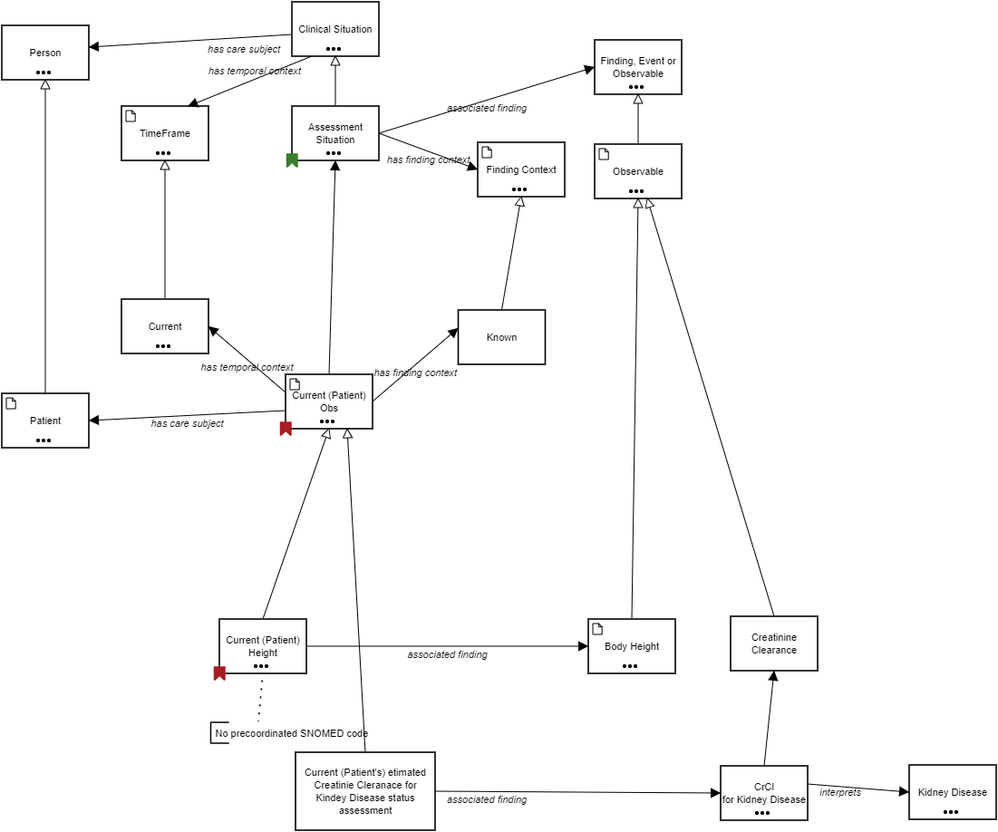

## Terms

**Clinical Situation**

**Relations**

* Assessment Situation *is a* Clinical Situation
* Intervention Situation *is a* Clinical Situation
* Clinical Situation *has care subject* Person
* Clinical Situation *has temporal context* TimeFrame

**Custom**

|  |  |
| --- | --- |
| SNOMED | http://snomed.info/id/243796009 |

**Person**

**Relations**

* Patient *is a* Person
* Subject of Record *is a* Person
* anf:Statement *anf:subjectOfInformation* Person
* Clinical Situation *has care subject* Person

**Examples**

Patient, Family member, Subject of Record

**Custom**

|  |  |
| --- | --- |
| SNOMED | http://snomed.info/id/125676002 |

**Finding, Event or Observable**

**Relations**

* Observable *is a* Finding, Event or Observable
* anf:Measure *about* Finding, Event or Observable
* anf:Measure *constrains* Finding, Event or Observable
* Assessment Situation *associated finding* Finding, Event or Observable

**TimeFrame**

**Data Type**

|  |  |
| --- | --- |
| Type | fhirPeriod |

**Relations**

* Current *is a* TimeFrame
* anf:Measure *about* TimeFrame
* anf:Repetition *about* TimeFrame
* Clinical Situation *has temporal context* TimeFrame

**Examples**

Current(ly), Past, Recent, Specified Time

**Custom**

|  |  |
| --- | --- |
| SNOMED | http://snomed.info/id/410510008 |

**Assessment Situation**

**Relations**

* Assessment Situation *is a* Clinical Situation
* Current (Patient) Obs *is a* Assessment Situation
* Assessment Situation *associated finding* Finding
* Assessment Situation *associated finding* Finding, Event or Observable
* Assessment Situation *has finding context* Finding Context
* Current (Patient) Obs *is related to* Assessment Situation
* Intervention Situation *establishes* Assessment Situation

**Custom**

|  |  |
| --- | --- |
| SNOMED | http://snomed.info/id/413350009 |

**Finding Context**

**Data Type**

|  |  |
| --- | --- |
| Type | fhirStatus |

**Relations**

* Known *is a* Finding Context
* anf:Measure *about* Finding Context
* Assessment Situation *has finding context* Finding Context

**Examples**

Known, At risk, Goal

**Custom**

|  |  |
| --- | --- |
| SNOMED | http://snomed.info/id/410514004 |

**Observable**

**Data Type**

|  |  |
| --- | --- |
| Type | fhirCodeableConcept |

**Relations**

* Body Height *is a* Observable
* Creatinine Clearance *is a* Observable
* Observable *is a* Finding, Event or Observable
* Evaluation Procedure *property* Observable

**Custom**

|  |  |
| --- | --- |
| SNOMED | http://snomed.info/id/363787002 |

**Current**

**Relations**

* Current *is a* TimeFrame
* Current (Patient) Height Evaluation *has temporal context* Current
* Current (Patient) Obs *has temporal context* Current

**Custom**

|  |  |
| --- | --- |
| SNOMED | http://snomed.info/id/15240007 |

**Known**

**Relations**

* Known *is a* Finding Context
* Current (Patient) Obs *has finding context* Known

**Custom**

|  |  |
| --- | --- |
| SNOMED | http://snomed.info/id/36692007 |

**Current (Patient) Obs**

**Data Type**

|  |  |
| --- | --- |
| Type | fhirObservation |

**Relations**

* Current (Patient's) etimated Creatinie Cleranace for Kindey Disease status assessment *is a* Current (Patient) Obs
* Current (Patient) Height *is a* Current (Patient) Obs
* Current (Patient) Obs *is a* Assessment Situation
* Patient Has Kidney Disease *is a* Current (Patient) Obs
* Current (Patient) Obs *has care subject* Patient
* Current (Patient) Obs *has finding context* Known
* Current (Patient) Obs *has temporal context* Current
* Current (Patient) Obs *is related to* Assessment Situation

**Patient**

**Data Type**

|  |  |
| --- | --- |
| Type | fhirPatient |

**Relations**

* Patient *is a* Person
* Current (Patient) Obs *has care subject* Patient

**Custom**

|  |  |
| --- | --- |
| SNOMED | http://snomed.info/id/125676002 |

**Current (Patient) Height**

**Description**

413350009 | Finding with explicit context (situation) | :

408732007 | Subject relationship context (attribute) | = 116154003 | Patient (person) |,

246090004 | Associated finding (attribute) | = 50373000 | Body height measure (observable entity) |,

408731000 | Temporal context (attribute) | = 15240007 | Current (qualifier value) |,

408729009 | Finding context (attribute) | = 36692007 | Known (qualifier value) |

**Relations**

* Current (Patient) Height *is a* Current (Patient) Obs
* Current (Patient) Height *associated finding* Body Height
* Current (Patient) Height *associated finding* General Finding of Height

**Examples**

**Body Height**

**Data Type**

|  |  |
| --- | --- |
| Type | fhirQuantity |

**Relations**

* Body Height *is a* Observable
* Current (Patient) Height *associated finding* Body Height
* General Finding of Height *interprets* Body Height

**Custom**

|  |  |
| --- | --- |
| SNOMED | http://snomed.info/id/50373000 |

**Creatinine Clearance**

**Relations**

* Creatinine Clearance *is a* Observable
* CrCl for Kidney Disease *is related to* Creatinine Clearance

**Custom**

|  |  |
| --- | --- |
| SNOMED | http://snomed.info/id/102811001 |

**Current (Patient's) etimated Creatinie Cleranace for Kindey Disease status assessment**

**Relations**

* Current (Patient's) etimated Creatinie Cleranace for Kindey Disease status assessment *is a* Current (Patient) Obs
* Current (Patient's) etimated Creatinie Cleranace for Kindey Disease status assessment *associated finding* CrCl for Kidney Disease

**CrCl for Kidney Disease**

**Relations**

* CrCl for Kidney Disease *interprets* Kidney Disease
* CrCl for Kidney Disease *is related to* Creatinine Clearance
* Current (Patient's) etimated Creatinie Cleranace for Kindey Disease status assessment *associated finding* CrCl for Kidney Disease

**Kidney Disease**

**Relations**

* CrCl for Kidney Disease *interprets* Kidney Disease
* Patient Has Kidney Disease *associated finding* Kidney Disease

**Custom**

|  |  |
| --- | --- |
| SNOMED | http://snomed.info/id/90708001 |

# Vernacular

## Diagram

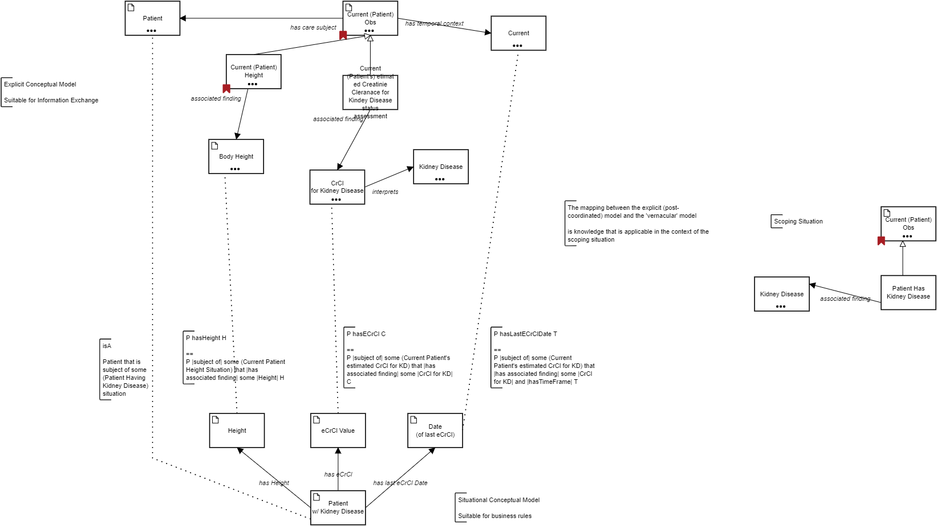

## Terms

**Patient**

**Data Type**

|  |  |
| --- | --- |
| Type | fhirPatient |

**Relations**

* Patient *is a* Person
* Current (Patient) Obs *has care subject* Patient

**Custom**

|  |  |
| --- | --- |
| SNOMED | http://snomed.info/id/125676002 |

**Current (Patient) Obs**

**Data Type**

|  |  |
| --- | --- |
| Type | fhirObservation |

**Relations**

* Current (Patient's) etimated Creatinie Cleranace for Kindey Disease status assessment *is a* Current (Patient) Obs
* Current (Patient) Height *is a* Current (Patient) Obs
* Current (Patient) Obs *is a* Assessment Situation
* Patient Has Kidney Disease *is a* Current (Patient) Obs
* Current (Patient) Obs *has care subject* Patient
* Current (Patient) Obs *has finding context* Known
* Current (Patient) Obs *has temporal context* Current
* Current (Patient) Obs *is related to* Assessment Situation

**Current**

**Relations**

* Current *is a* TimeFrame
* Current (Patient) Height Evaluation *has temporal context* Current
* Current (Patient) Obs *has temporal context* Current

**Custom**

|  |  |
| --- | --- |
| SNOMED | http://snomed.info/id/15240007 |

**Current (Patient) Height**

**Description**

413350009 | Finding with explicit context (situation) | :

408732007 | Subject relationship context (attribute) | = 116154003 | Patient (person) |,

246090004 | Associated finding (attribute) | = 50373000 | Body height measure (observable entity) |,

408731000 | Temporal context (attribute) | = 15240007 | Current (qualifier value) |,

408729009 | Finding context (attribute) | = 36692007 | Known (qualifier value) |

**Relations**

* Current (Patient) Height *is a* Current (Patient) Obs
* Current (Patient) Height *associated finding* Body Height
* Current (Patient) Height *associated finding* General Finding of Height

**Examples**

**Current (Patient's) etimated Creatinie Cleranace for Kindey Disease status assessment**

**Relations**

* Current (Patient's) etimated Creatinie Cleranace for Kindey Disease status assessment *is a* Current (Patient) Obs
* Current (Patient's) etimated Creatinie Cleranace for Kindey Disease status assessment *associated finding* CrCl for Kidney Disease

**Body Height**

**Data Type**

|  |  |
| --- | --- |
| Type | fhirQuantity |

**Relations**

* Body Height *is a* Observable
* Current (Patient) Height *associated finding* Body Height
* General Finding of Height *interprets* Body Height

**Custom**

|  |  |
| --- | --- |
| SNOMED | http://snomed.info/id/50373000 |

**Kidney Disease**

**Relations**

* CrCl for Kidney Disease *interprets* Kidney Disease
* Patient Has Kidney Disease *associated finding* Kidney Disease

**Custom**

|  |  |
| --- | --- |
| SNOMED | http://snomed.info/id/90708001 |

**CrCl for Kidney Disease**

**Relations**

* CrCl for Kidney Disease *interprets* Kidney Disease
* CrCl for Kidney Disease *is related to* Creatinine Clearance
* Current (Patient's) etimated Creatinie Cleranace for Kindey Disease status assessment *associated finding* CrCl for Kidney Disease

**Current (Patient) Obs**

**Data Type**

|  |  |
| --- | --- |
| Type | fhirObservation |

**Relations**

* Current (Patient's) etimated Creatinie Cleranace for Kindey Disease status assessment *is a* Current (Patient) Obs
* Current (Patient) Height *is a* Current (Patient) Obs
* Current (Patient) Obs *is a* Assessment Situation
* Patient Has Kidney Disease *is a* Current (Patient) Obs
* Current (Patient) Obs *has care subject* Patient
* Current (Patient) Obs *has finding context* Known
* Current (Patient) Obs *has temporal context* Current
* Current (Patient) Obs *is related to* Assessment Situation

**Patient Has Kidney Disease**

**Relations**

* Patient Has Kidney Disease *is a* Current (Patient) Obs
* Patient Has Kidney Disease *associated finding* Kidney Disease

**Kidney Disease**

**Relations**

* CrCl for Kidney Disease *interprets* Kidney Disease
* Patient Has Kidney Disease *associated finding* Kidney Disease

**Custom**

|  |  |
| --- | --- |
| SNOMED | http://snomed.info/id/90708001 |

**Height**

**Data Type**

|  |  |
| --- | --- |
| Type | localQuantity |

**Relations**

* Patient w/ Kidney Disease *has Height* Height

**eCrCl Value**

**Data Type**

|  |  |
| --- | --- |
| Type | localQuantity |

**Relations**

* Patient w/ Kidney Disease *has eCrCl* eCrCl Value

**Date (of last eCrCl)**

**Data Type**

|  |  |
| --- | --- |
| Type | Date and time |

**Relations**

* Patient w/ Kidney Disease *has last eCrCl Date* Date (of last eCrCl)

**Patient w/ Kidney Disease**

**Data Type**

|  |  |
| --- | --- |
| Type | KidneyPatient |

**Relations**

* Patient w/ Kidney Disease *has eCrCl* eCrCl Value
* Patient w/ Kidney Disease *has Height* Height
* Patient w/ Kidney Disease *has last eCrCl Date* Date (of last eCrCl)

# Logical Data Model

## Diagram

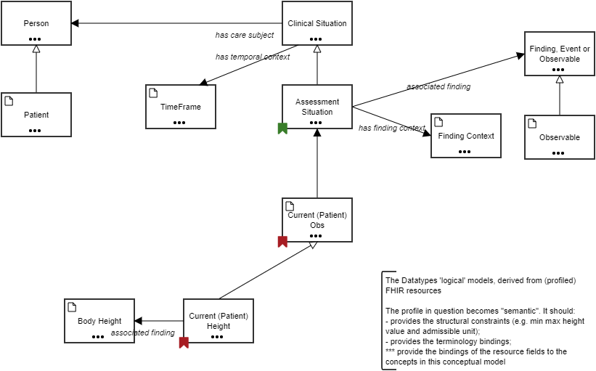

## Terms

**Person**

**Relations**

* Patient *is a* Person
* Subject of Record *is a* Person
* anf:Statement *anf:subjectOfInformation* Person
* Clinical Situation *has care subject* Person

**Examples**

Patient, Family member, Subject of Record

**Custom**

|  |  |
| --- | --- |
| SNOMED | http://snomed.info/id/125676002 |

**Clinical Situation**

**Relations**

* Assessment Situation *is a* Clinical Situation
* Intervention Situation *is a* Clinical Situation
* Clinical Situation *has care subject* Person
* Clinical Situation *has temporal context* TimeFrame

**Custom**

|  |  |
| --- | --- |
| SNOMED | http://snomed.info/id/243796009 |

**Finding, Event or Observable**

**Relations**

* Observable *is a* Finding, Event or Observable
* anf:Measure *about* Finding, Event or Observable
* anf:Measure *constrains* Finding, Event or Observable
* Assessment Situation *associated finding* Finding, Event or Observable

**TimeFrame**

**Data Type**

|  |  |
| --- | --- |
| Type | fhirPeriod |

**Relations**

* Current *is a* TimeFrame
* anf:Measure *about* TimeFrame
* anf:Repetition *about* TimeFrame
* Clinical Situation *has temporal context* TimeFrame

**Examples**

Current(ly), Past, Recent, Specified Time

**Custom**

|  |  |
| --- | --- |
| SNOMED | http://snomed.info/id/410510008 |

**Assessment Situation**

**Relations**

* Assessment Situation *is a* Clinical Situation
* Current (Patient) Obs *is a* Assessment Situation
* Assessment Situation *associated finding* Finding
* Assessment Situation *associated finding* Finding, Event or Observable
* Assessment Situation *has finding context* Finding Context
* Current (Patient) Obs *is related to* Assessment Situation
* Intervention Situation *establishes* Assessment Situation

**Custom**

|  |  |
| --- | --- |
| SNOMED | http://snomed.info/id/413350009 |

**Patient**

**Data Type**

|  |  |
| --- | --- |
| Type | fhirPatient |

**Relations**

* Patient *is a* Person
* Current (Patient) Obs *has care subject* Patient

**Custom**

|  |  |
| --- | --- |
| SNOMED | http://snomed.info/id/125676002 |

**Finding Context**

**Data Type**

|  |  |
| --- | --- |
| Type | fhirStatus |

**Relations**

* Known *is a* Finding Context
* anf:Measure *about* Finding Context
* Assessment Situation *has finding context* Finding Context

**Examples**

Known, At risk, Goal

**Custom**

|  |  |
| --- | --- |
| SNOMED | http://snomed.info/id/410514004 |

**Observable**

**Data Type**

|  |  |
| --- | --- |
| Type | fhirCodeableConcept |

**Relations**

* Body Height *is a* Observable
* Creatinine Clearance *is a* Observable
* Observable *is a* Finding, Event or Observable
* Evaluation Procedure *property* Observable

**Custom**

|  |  |
| --- | --- |
| SNOMED | http://snomed.info/id/363787002 |

**Current (Patient) Obs**

**Data Type**

|  |  |
| --- | --- |
| Type | fhirObservation |

**Relations**

* Current (Patient's) etimated Creatinie Cleranace for Kindey Disease status assessment *is a* Current (Patient) Obs
* Current (Patient) Height *is a* Current (Patient) Obs
* Current (Patient) Obs *is a* Assessment Situation
* Patient Has Kidney Disease *is a* Current (Patient) Obs
* Current (Patient) Obs *has care subject* Patient
* Current (Patient) Obs *has finding context* Known
* Current (Patient) Obs *has temporal context* Current
* Current (Patient) Obs *is related to* Assessment Situation

**Body Height**

**Data Type**

|  |  |
| --- | --- |
| Type | fhirQuantity |

**Relations**

* Body Height *is a* Observable
* Current (Patient) Height *associated finding* Body Height
* General Finding of Height *interprets* Body Height

**Custom**

|  |  |
| --- | --- |
| SNOMED | http://snomed.info/id/50373000 |

**Current (Patient) Height**

**Description**

413350009 | Finding with explicit context (situation) | :

408732007 | Subject relationship context (attribute) | = 116154003 | Patient (person) |,

246090004 | Associated finding (attribute) | = 50373000 | Body height measure (observable entity) |,

408731000 | Temporal context (attribute) | = 15240007 | Current (qualifier value) |,

408729009 | Finding context (attribute) | = 36692007 | Known (qualifier value) |

**Relations**

* Current (Patient) Height *is a* Current (Patient) Obs
* Current (Patient) Height *associated finding* Body Height
* Current (Patient) Height *associated finding* General Finding of Height

**Examples**

# Situational (Data) Model

## Diagram

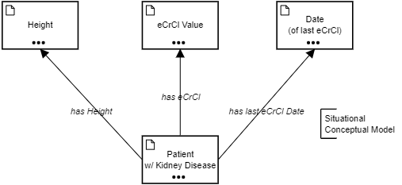

## Terms

**Height**

**Data Type**

|  |  |
| --- | --- |
| Type | localQuantity |

**Relations**

* Patient w/ Kidney Disease *has Height* Height

**eCrCl Value**

**Data Type**

|  |  |
| --- | --- |
| Type | localQuantity |

**Relations**

* Patient w/ Kidney Disease *has eCrCl* eCrCl Value

**Date (of last eCrCl)**

**Data Type**

|  |  |
| --- | --- |
| Type | Date and time |

**Relations**

* Patient w/ Kidney Disease *has last eCrCl Date* Date (of last eCrCl)

**Patient w/ Kidney Disease**

**Data Type**

|  |  |
| --- | --- |
| Type | KidneyPatient |

**Relations**

* Patient w/ Kidney Disease *has eCrCl* eCrCl Value
* Patient w/ Kidney Disease *has Height* Height
* Patient w/ Kidney Disease *has last eCrCl Date* Date (of last eCrCl)

# Extended Business Concepts

## Diagram

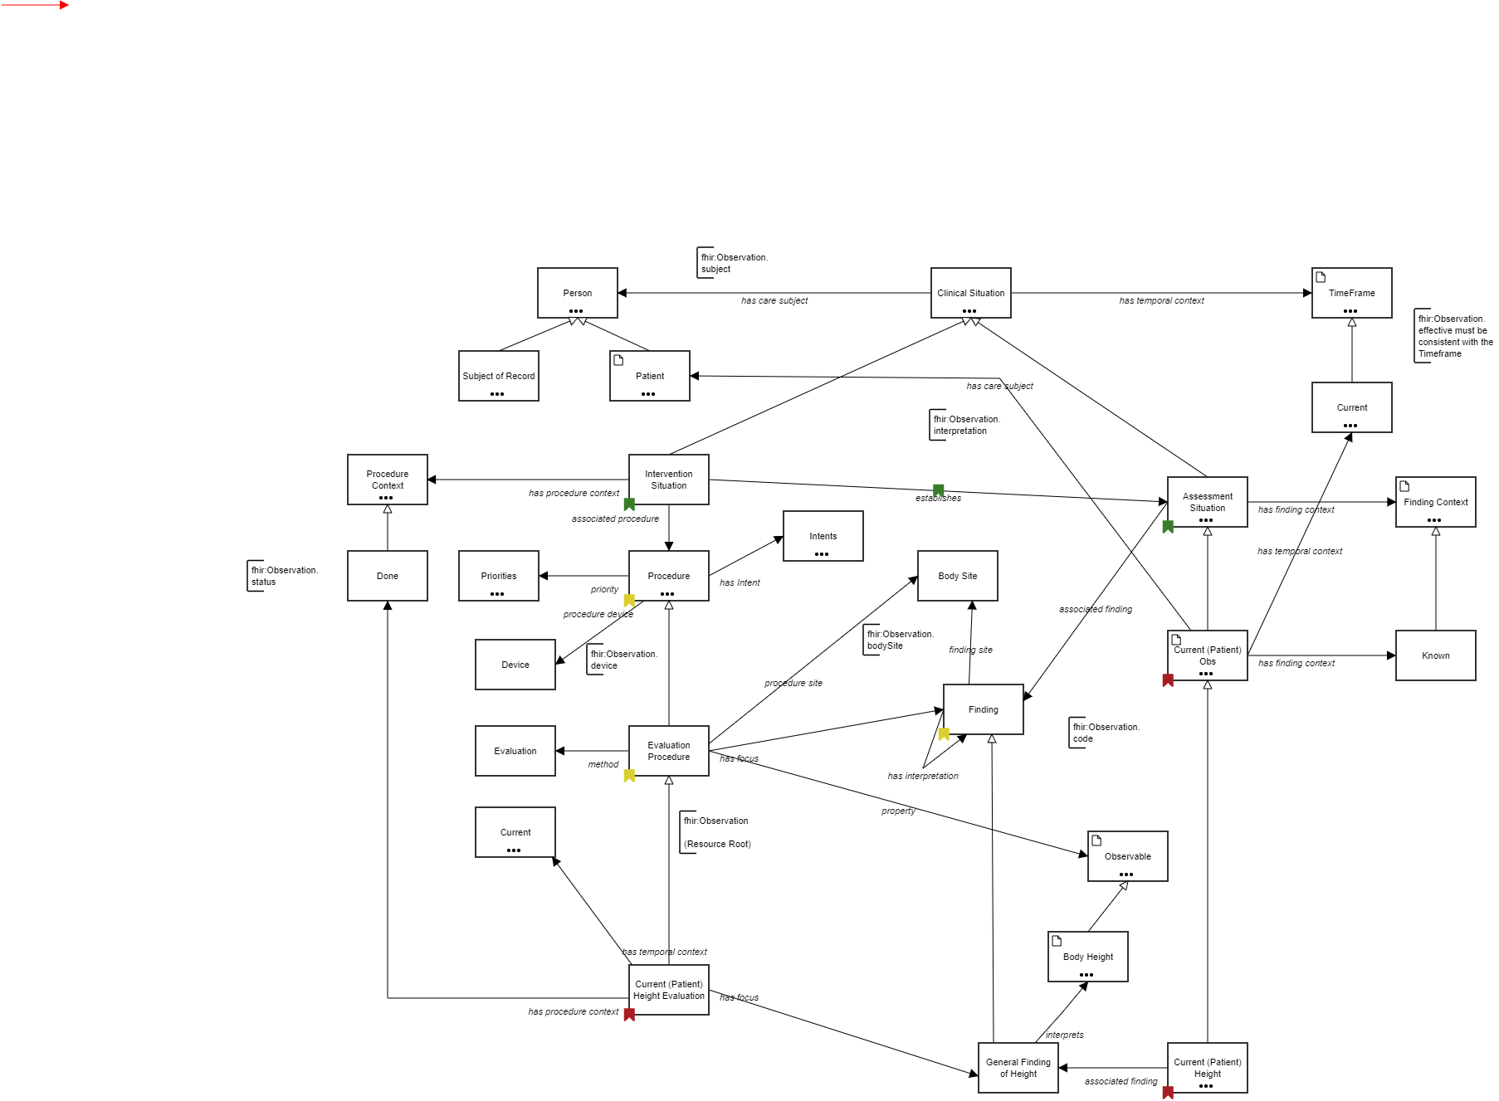

## Terms

**Person**

**Relations**

* Patient *is a* Person
* Subject of Record *is a* Person
* anf:Statement *anf:subjectOfInformation* Person
* Clinical Situation *has care subject* Person

**Examples**

Patient, Family member, Subject of Record

**Custom**

|  |  |
| --- | --- |
| SNOMED | http://snomed.info/id/125676002 |

**Clinical Situation**

**Relations**

* Assessment Situation *is a* Clinical Situation
* Intervention Situation *is a* Clinical Situation
* Clinical Situation *has care subject* Person
* Clinical Situation *has temporal context* TimeFrame

**Custom**

|  |  |
| --- | --- |
| SNOMED | http://snomed.info/id/243796009 |

**TimeFrame**

**Data Type**

|  |  |
| --- | --- |
| Type | fhirPeriod |

**Relations**

* Current *is a* TimeFrame
* anf:Measure *about* TimeFrame
* anf:Repetition *about* TimeFrame
* Clinical Situation *has temporal context* TimeFrame

**Examples**

Current(ly), Past, Recent, Specified Time

**Custom**

|  |  |
| --- | --- |
| SNOMED | http://snomed.info/id/410510008 |

**Subject of Record**

**Relations**

* Subject of Record *is a* Person
* anf:Participant *about* Subject of Record

**Patient**

**Data Type**

|  |  |
| --- | --- |
| Type | fhirPatient |

**Relations**

* Patient *is a* Person
* Current (Patient) Obs *has care subject* Patient

**Custom**

|  |  |
| --- | --- |
| SNOMED | http://snomed.info/id/125676002 |

**Current**

**Relations**

* Current *is a* TimeFrame
* Current (Patient) Height Evaluation *has temporal context* Current
* Current (Patient) Obs *has temporal context* Current

**Custom**

|  |  |
| --- | --- |
| SNOMED | http://snomed.info/id/15240007 |

**Procedure Context**

**Relations**

* Done *is a* Procedure Context
* anf:Circumstance *anf:status* Procedure Context
* Intervention Situation *has procedure context* Procedure Context

**Examples**

Indicated, Scheduled, Started

**Custom**

|  |  |
| --- | --- |
| SNOMED | http://snomed.info/id/288532009 |

**Intervention Situation**

**Relations**

* Intervention Situation *is a* Clinical Situation
* Intervention Situation *associated procedure* Procedure
* Intervention Situation *establishes* Assessment Situation
* Intervention Situation *has procedure context* Procedure Context

**Custom**

|  |  |
| --- | --- |
| SNOMED | http://snomed.info/id/129125009 |

**Assessment Situation**

**Relations**

* Assessment Situation *is a* Clinical Situation
* Current (Patient) Obs *is a* Assessment Situation
* Assessment Situation *associated finding* Finding
* Assessment Situation *associated finding* Finding, Event or Observable
* Assessment Situation *has finding context* Finding Context
* Current (Patient) Obs *is related to* Assessment Situation
* Intervention Situation *establishes* Assessment Situation

**Custom**

|  |  |
| --- | --- |
| SNOMED | http://snomed.info/id/413350009 |

**Finding Context**

**Data Type**

|  |  |
| --- | --- |
| Type | fhirStatus |

**Relations**

* Known *is a* Finding Context
* anf:Measure *about* Finding Context
* Assessment Situation *has finding context* Finding Context

**Examples**

Known, At risk, Goal

**Custom**

|  |  |
| --- | --- |
| SNOMED | http://snomed.info/id/410514004 |

**Intents**

**Relations**

* anf:Circumstance *anf:purpose ???* Intents
* Procedure *has Intent* Intents

**Done**

**Relations**

* Done *is a* Procedure Context
* Current (Patient) Height Evaluation *has procedure context* Done

**Priorities**

**Relations**

* anf:RequestCircumstance *anf:priority* Priorities
* Procedure *priority* Priorities

**Procedure**

**Relations**

* Evaluation Procedure *is a* Procedure
* anf:Statement *anf:topic* Procedure
* Intervention Situation *associated procedure* Procedure
* Procedure *has Intent* Intents
* Procedure *priority* Priorities
* Procedure *procedure device* Device

**Custom**

|  |  |
| --- | --- |
| SNOMED | http://snomed.info/id/71388002 |

**Body Site**

**Relations**

* Evaluation Procedure *procedure site* Body Site
* Finding *finding site* Body Site

**Current (Patient) Obs**

**Data Type**

|  |  |
| --- | --- |
| Type | fhirObservation |

**Relations**

* Current (Patient's) etimated Creatinie Cleranace for Kindey Disease status assessment *is a* Current (Patient) Obs
* Current (Patient) Height *is a* Current (Patient) Obs
* Current (Patient) Obs *is a* Assessment Situation
* Patient Has Kidney Disease *is a* Current (Patient) Obs
* Current (Patient) Obs *has care subject* Patient
* Current (Patient) Obs *has finding context* Known
* Current (Patient) Obs *has temporal context* Current
* Current (Patient) Obs *is related to* Assessment Situation

**Known**

**Relations**

* Known *is a* Finding Context
* Current (Patient) Obs *has finding context* Known

**Custom**

|  |  |
| --- | --- |
| SNOMED | http://snomed.info/id/36692007 |

**Device**

**Relations**

* Procedure *procedure device* Device

**Finding**

**Relations**

* General Finding of Height *is a* Finding
* Assessment Situation *associated finding* Finding
* Evaluation Procedure *has focus* Finding
* Finding *finding site* Body Site
* Finding *has interpretation* Finding

**Evaluation**

**Relations**

* Evaluation Procedure *method* Evaluation

**Custom**

|  |  |
| --- | --- |
| SNOMED | http://snomed.info/id/129265001 |

**Evaluation Procedure**

**Relations**

* Current (Patient) Height Evaluation *is a* Evaluation Procedure
* Evaluation Procedure *is a* Procedure
* Evaluation Procedure *has focus* Finding
* Evaluation Procedure *method* Evaluation
* Evaluation Procedure *procedure site* Body Site
* Evaluation Procedure *property* Observable

**Custom**

|  |  |
| --- | --- |
| SNOMED | http://snomed.info/id/386053000 |

**Current**

**Relations**

* Current *is a* TimeFrame
* Current (Patient) Height Evaluation *has temporal context* Current
* Current (Patient) Obs *has temporal context* Current

**Custom**

|  |  |
| --- | --- |
| SNOMED | http://snomed.info/id/15240007 |

**Observable**

**Data Type**

|  |  |
| --- | --- |
| Type | fhirCodeableConcept |

**Relations**

* Body Height *is a* Observable
* Creatinine Clearance *is a* Observable
* Observable *is a* Finding, Event or Observable
* Evaluation Procedure *property* Observable

**Custom**

|  |  |
| --- | --- |
| SNOMED | http://snomed.info/id/363787002 |

**Body Height**

**Data Type**

|  |  |
| --- | --- |
| Type | fhirQuantity |

**Relations**

* Body Height *is a* Observable
* Current (Patient) Height *associated finding* Body Height
* General Finding of Height *interprets* Body Height

**Custom**

|  |  |
| --- | --- |
| SNOMED | http://snomed.info/id/50373000 |

**Current (Patient) Height Evaluation**

**Relations**

* Current (Patient) Height Evaluation *is a* Evaluation Procedure
* Current (Patient) Height Evaluation *has focus* General Finding of Height
* Current (Patient) Height Evaluation *has procedure context* Done
* Current (Patient) Height Evaluation *has temporal context* Current

**General Finding of Height**

**Relations**

* General Finding of Height *is a* Finding
* Current (Patient) Height *associated finding* General Finding of Height
* Current (Patient) Height Evaluation *has focus* General Finding of Height
* General Finding of Height *interprets* Body Height

**Current (Patient) Height**

**Description**

413350009 | Finding with explicit context (situation) | :

408732007 | Subject relationship context (attribute) | = 116154003 | Patient (person) |,

246090004 | Associated finding (attribute) | = 50373000 | Body height measure (observable entity) |,

408731000 | Temporal context (attribute) | = 15240007 | Current (qualifier value) |,

408729009 | Finding context (attribute) | = 36692007 | Known (qualifier value) |

**Relations**

* Current (Patient) Height *is a* Current (Patient) Obs
* Current (Patient) Height *associated finding* Body Height
* Current (Patient) Height *associated finding* General Finding of Height

**Examples**

# ANF Statement

## Diagram

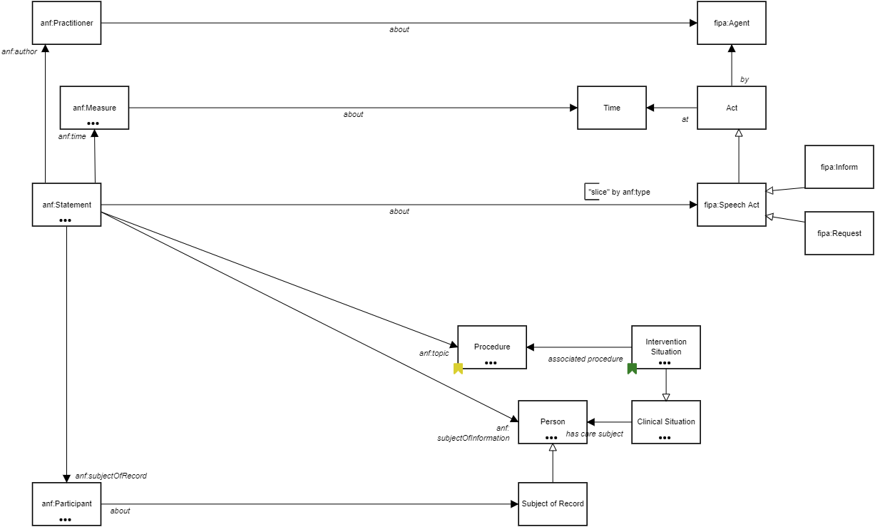

## Terms

**anf:Practitioner**

**Relations**

* anf:Practitioner *about* fipa:Agent
* anf:Statement *anf:author* anf:Practitioner

**fipa:Agent**

**Relations**

* Act *by* fipa:Agent
* anf:Practitioner *about* fipa:Agent

**anf:Measure**

**Relations**

* anf:Circumstance *anf:timing* anf:Measure
* anf:Measure *about* Finding Context
* anf:Measure *about* Finding, Event or Observable
* anf:Measure *about* Time
* anf:Measure *about* TimeFrame
* anf:Measure *constrains* Finding, Event or Observable
* anf:PerformanceCircumstance *anf:referenceRange* anf:Measure
* anf:PerformanceCircumstance *anf:result* anf:Measure
* anf:RequestCircumstance *anf:requestedResult* anf:Measure
* anf:Statement *anf:time* anf:Measure

**Time**

**Relations**

* Act *at* Time
* anf:Measure *about* Time

**Act**

**Relations**

* fipa:Speech Act *is a* Act
* Act *at* Time
* Act *by* fipa:Agent

**fipa:Inform**

**Relations**

* fipa:Inform *is a* fipa:Speech Act

**anf:Statement**

**Relations**

* anf:RequestCircumstance *anf:conditionalTrigger* anf:Statement
* anf:Statement *about* fipa:Speech Act
* anf:Statement *anf:author* anf:Practitioner
* anf:Statement *anf:Circumstance* anf:Circumstance
* anf:Statement *anf:subjectOfInformation* Person
* anf:Statement *anf:subjectOfRecord* anf:Participant
* anf:Statement *anf:time* anf:Measure
* anf:Statement *anf:topic* Procedure

**fipa:Speech Act**

**Relations**

* fipa:Inform *is a* fipa:Speech Act
* fipa:Request *is a* fipa:Speech Act
* fipa:Speech Act *is a* Act
* anf:Statement *about* fipa:Speech Act

**fipa:Request**

**Relations**

* fipa:Request *is a* fipa:Speech Act

**Procedure**

**Relations**

* Evaluation Procedure *is a* Procedure
* anf:Statement *anf:topic* Procedure
* Intervention Situation *associated procedure* Procedure
* Procedure *has Intent* Intents
* Procedure *priority* Priorities
* Procedure *procedure device* Device

**Custom**

|  |  |
| --- | --- |
| SNOMED | http://snomed.info/id/71388002 |

**Intervention Situation**

**Relations**

* Intervention Situation *is a* Clinical Situation
* Intervention Situation *associated procedure* Procedure
* Intervention Situation *establishes* Assessment Situation
* Intervention Situation *has procedure context* Procedure Context

**Custom**

|  |  |
| --- | --- |
| SNOMED | http://snomed.info/id/129125009 |

**Person**

**Relations**

* Patient *is a* Person
* Subject of Record *is a* Person
* anf:Statement *anf:subjectOfInformation* Person
* Clinical Situation *has care subject* Person

**Examples**

Patient, Family member, Subject of Record

**Custom**

|  |  |
| --- | --- |
| SNOMED | http://snomed.info/id/125676002 |

**Clinical Situation**

**Relations**

* Assessment Situation *is a* Clinical Situation
* Intervention Situation *is a* Clinical Situation
* Clinical Situation *has care subject* Person
* Clinical Situation *has temporal context* TimeFrame

**Custom**

|  |  |
| --- | --- |
| SNOMED | http://snomed.info/id/243796009 |

**anf:Participant**

**Relations**

* anf:Participant *about* Subject of Record
* anf:PerformanceCircumstance *anf:participant* anf:Participant
* anf:Reference *ref* anf:Participant
* anf:Statement *anf:subjectOfRecord* anf:Participant

**Subject of Record**

**Relations**

* Subject of Record *is a* Person
* anf:Participant *about* Subject of Record

# ANF Performance

## Diagram

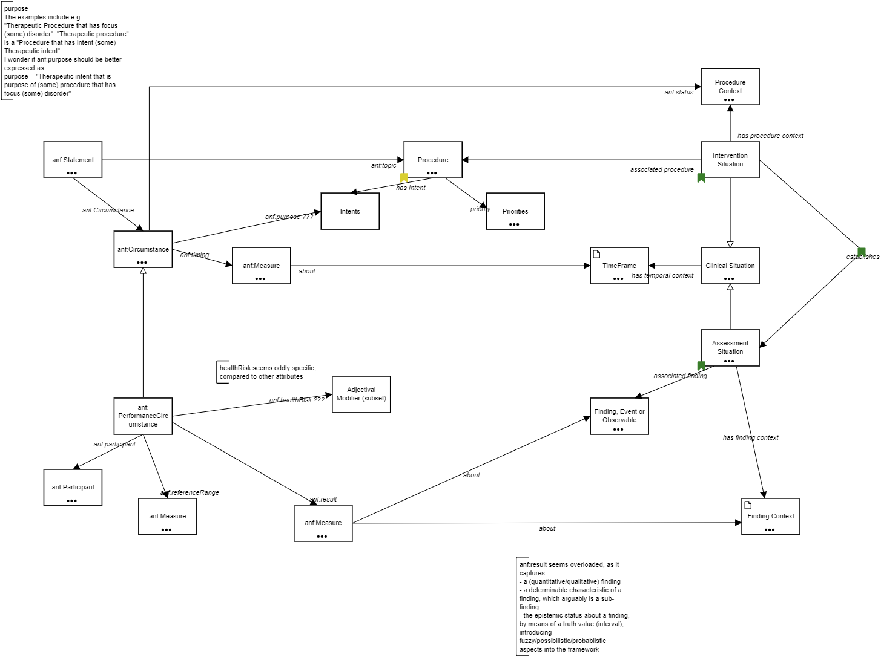

## Terms

**Procedure Context**

**Relations**

* Done *is a* Procedure Context
* anf:Circumstance *anf:status* Procedure Context
* Intervention Situation *has procedure context* Procedure Context

**Examples**

Indicated, Scheduled, Started

**Custom**

|  |  |
| --- | --- |
| SNOMED | http://snomed.info/id/288532009 |

**anf:Statement**

**Relations**

* anf:RequestCircumstance *anf:conditionalTrigger* anf:Statement
* anf:Statement *about* fipa:Speech Act
* anf:Statement *anf:author* anf:Practitioner
* anf:Statement *anf:Circumstance* anf:Circumstance
* anf:Statement *anf:subjectOfInformation* Person
* anf:Statement *anf:subjectOfRecord* anf:Participant
* anf:Statement *anf:time* anf:Measure
* anf:Statement *anf:topic* Procedure

**Procedure**

**Relations**

* Evaluation Procedure *is a* Procedure
* anf:Statement *anf:topic* Procedure
* Intervention Situation *associated procedure* Procedure
* Procedure *has Intent* Intents
* Procedure *priority* Priorities
* Procedure *procedure device* Device

**Custom**

|  |  |
| --- | --- |
| SNOMED | http://snomed.info/id/71388002 |

**Intervention Situation**

**Relations**

* Intervention Situation *is a* Clinical Situation
* Intervention Situation *associated procedure* Procedure
* Intervention Situation *establishes* Assessment Situation
* Intervention Situation *has procedure context* Procedure Context

**Custom**

|  |  |
| --- | --- |
| SNOMED | http://snomed.info/id/129125009 |

**Intents**

**Relations**

* anf:Circumstance *anf:purpose ???* Intents
* Procedure *has Intent* Intents

**Priorities**

**Relations**

* anf:RequestCircumstance *anf:priority* Priorities
* Procedure *priority* Priorities

**anf:Circumstance**

**Relations**

* anf:PerformanceCircumstance *is a* anf:Circumstance
* anf:RequestCircumstance *is a* anf:Circumstance
* anf:Circumstance *anf:purpose ???* Intents
* anf:Circumstance *anf:status* Procedure Context
* anf:Circumstance *anf:timing* anf:Measure
* anf:Statement *anf:Circumstance* anf:Circumstance

**anf:Measure**

**Relations**

* anf:Circumstance *anf:timing* anf:Measure
* anf:Measure *about* Finding Context
* anf:Measure *about* Finding, Event or Observable
* anf:Measure *about* Time
* anf:Measure *about* TimeFrame
* anf:Measure *constrains* Finding, Event or Observable
* anf:PerformanceCircumstance *anf:referenceRange* anf:Measure
* anf:PerformanceCircumstance *anf:result* anf:Measure
* anf:RequestCircumstance *anf:requestedResult* anf:Measure
* anf:Statement *anf:time* anf:Measure

**TimeFrame**

**Data Type**

|  |  |
| --- | --- |
| Type | fhirPeriod |

**Relations**

* Current *is a* TimeFrame
* anf:Measure *about* TimeFrame
* anf:Repetition *about* TimeFrame
* Clinical Situation *has temporal context* TimeFrame

**Examples**

Current(ly), Past, Recent, Specified Time

**Custom**

|  |  |
| --- | --- |
| SNOMED | http://snomed.info/id/410510008 |

**Clinical Situation**

**Relations**

* Assessment Situation *is a* Clinical Situation
* Intervention Situation *is a* Clinical Situation
* Clinical Situation *has care subject* Person
* Clinical Situation *has temporal context* TimeFrame

**Custom**

|  |  |
| --- | --- |
| SNOMED | http://snomed.info/id/243796009 |

**Assessment Situation**

**Relations**

* Assessment Situation *is a* Clinical Situation
* Current (Patient) Obs *is a* Assessment Situation
* Assessment Situation *associated finding* Finding
* Assessment Situation *associated finding* Finding, Event or Observable
* Assessment Situation *has finding context* Finding Context
* Current (Patient) Obs *is related to* Assessment Situation
* Intervention Situation *establishes* Assessment Situation

**Custom**

|  |  |
| --- | --- |
| SNOMED | http://snomed.info/id/413350009 |

**Adjectival Modifier (subset)**

**Relations**

* anf:PerformanceCircumstance *anf:healthRisk ???* Adjectival Modifier (subset)

**anf:PerformanceCircumstance**

**Relations**

* anf:PerformanceCircumstance *is a* anf:Circumstance
* anf:PerformanceCircumstance *anf:healthRisk ???* Adjectival Modifier (subset)
* anf:PerformanceCircumstance *anf:participant* anf:Participant
* anf:PerformanceCircumstance *anf:referenceRange* anf:Measure
* anf:PerformanceCircumstance *anf:result* anf:Measure

**Finding, Event or Observable**

**Relations**

* Observable *is a* Finding, Event or Observable
* anf:Measure *about* Finding, Event or Observable
* anf:Measure *constrains* Finding, Event or Observable
* Assessment Situation *associated finding* Finding, Event or Observable

**anf:Participant**

**Relations**

* anf:Participant *about* Subject of Record
* anf:PerformanceCircumstance *anf:participant* anf:Participant
* anf:Reference *ref* anf:Participant
* anf:Statement *anf:subjectOfRecord* anf:Participant

**anf:Measure**

**Relations**

* anf:Circumstance *anf:timing* anf:Measure
* anf:Measure *about* Finding Context
* anf:Measure *about* Finding, Event or Observable
* anf:Measure *about* Time
* anf:Measure *about* TimeFrame
* anf:Measure *constrains* Finding, Event or Observable
* anf:PerformanceCircumstance *anf:referenceRange* anf:Measure
* anf:PerformanceCircumstance *anf:result* anf:Measure
* anf:RequestCircumstance *anf:requestedResult* anf:Measure
* anf:Statement *anf:time* anf:Measure

**Finding Context**

**Data Type**

|  |  |
| --- | --- |
| Type | fhirStatus |

**Relations**

* Known *is a* Finding Context
* anf:Measure *about* Finding Context
* Assessment Situation *has finding context* Finding Context

**Examples**

Known, At risk, Goal

**Custom**

|  |  |
| --- | --- |
| SNOMED | http://snomed.info/id/410514004 |

**anf:Measure**

**Relations**

* anf:Circumstance *anf:timing* anf:Measure
* anf:Measure *about* Finding Context
* anf:Measure *about* Finding, Event or Observable
* anf:Measure *about* Time
* anf:Measure *about* TimeFrame
* anf:Measure *constrains* Finding, Event or Observable
* anf:PerformanceCircumstance *anf:referenceRange* anf:Measure
* anf:PerformanceCircumstance *anf:result* anf:Measure
* anf:RequestCircumstance *anf:requestedResult* anf:Measure
* anf:Statement *anf:time* anf:Measure

# ANF Request

## Diagram

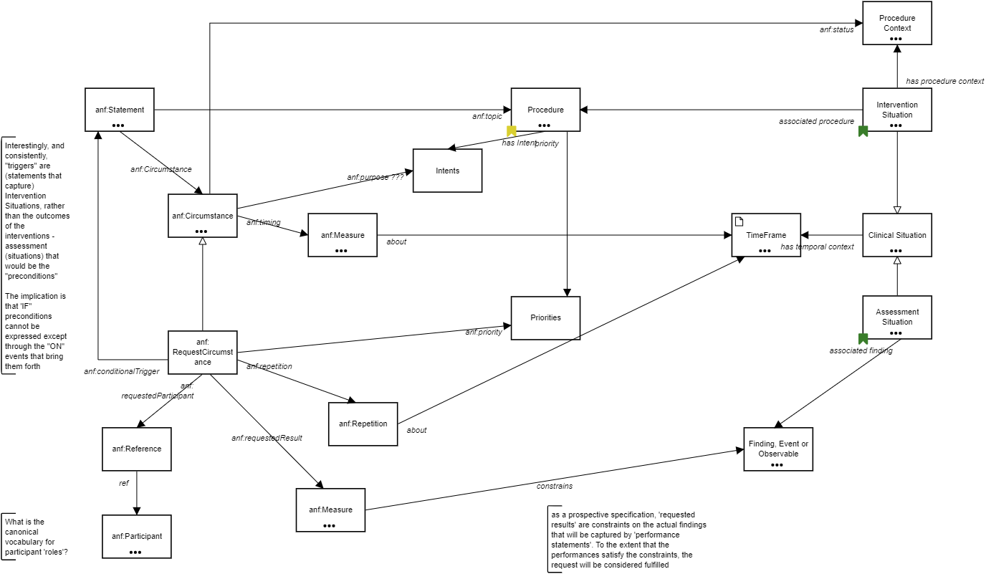

## Terms

**Procedure Context**

**Relations**

* Done *is a* Procedure Context
* anf:Circumstance *anf:status* Procedure Context
* Intervention Situation *has procedure context* Procedure Context

**Examples**

Indicated, Scheduled, Started

**Custom**

|  |  |
| --- | --- |
| SNOMED | http://snomed.info/id/288532009 |

**anf:Statement**

**Relations**

* anf:RequestCircumstance *anf:conditionalTrigger* anf:Statement
* anf:Statement *about* fipa:Speech Act
* anf:Statement *anf:author* anf:Practitioner
* anf:Statement *anf:Circumstance* anf:Circumstance
* anf:Statement *anf:subjectOfInformation* Person
* anf:Statement *anf:subjectOfRecord* anf:Participant
* anf:Statement *anf:time* anf:Measure
* anf:Statement *anf:topic* Procedure

**Procedure**

**Relations**

* Evaluation Procedure *is a* Procedure
* anf:Statement *anf:topic* Procedure
* Intervention Situation *associated procedure* Procedure
* Procedure *has Intent* Intents
* Procedure *priority* Priorities
* Procedure *procedure device* Device

**Custom**

|  |  |
| --- | --- |
| SNOMED | http://snomed.info/id/71388002 |

**Intervention Situation**

**Relations**

* Intervention Situation *is a* Clinical Situation
* Intervention Situation *associated procedure* Procedure
* Intervention Situation *establishes* Assessment Situation
* Intervention Situation *has procedure context* Procedure Context

**Custom**

|  |  |
| --- | --- |
| SNOMED | http://snomed.info/id/129125009 |

**Intents**

**Relations**

* anf:Circumstance *anf:purpose ???* Intents
* Procedure *has Intent* Intents

**anf:Circumstance**

**Relations**

* anf:PerformanceCircumstance *is a* anf:Circumstance
* anf:RequestCircumstance *is a* anf:Circumstance
* anf:Circumstance *anf:purpose ???* Intents
* anf:Circumstance *anf:status* Procedure Context
* anf:Circumstance *anf:timing* anf:Measure
* anf:Statement *anf:Circumstance* anf:Circumstance

**anf:Measure**

**Relations**

* anf:Circumstance *anf:timing* anf:Measure
* anf:Measure *about* Finding Context
* anf:Measure *about* Finding, Event or Observable
* anf:Measure *about* Time
* anf:Measure *about* TimeFrame
* anf:Measure *constrains* Finding, Event or Observable
* anf:PerformanceCircumstance *anf:referenceRange* anf:Measure
* anf:PerformanceCircumstance *anf:result* anf:Measure
* anf:RequestCircumstance *anf:requestedResult* anf:Measure
* anf:Statement *anf:time* anf:Measure

**TimeFrame**

**Data Type**

|  |  |
| --- | --- |
| Type | fhirPeriod |

**Relations**

* Current *is a* TimeFrame
* anf:Measure *about* TimeFrame
* anf:Repetition *about* TimeFrame
* Clinical Situation *has temporal context* TimeFrame

**Examples**

Current(ly), Past, Recent, Specified Time

**Custom**

|  |  |
| --- | --- |
| SNOMED | http://snomed.info/id/410510008 |

**Clinical Situation**

**Relations**

* Assessment Situation *is a* Clinical Situation
* Intervention Situation *is a* Clinical Situation
* Clinical Situation *has care subject* Person
* Clinical Situation *has temporal context* TimeFrame

**Custom**

|  |  |
| --- | --- |
| SNOMED | http://snomed.info/id/243796009 |

**Priorities**

**Relations**

* anf:RequestCircumstance *anf:priority* Priorities
* Procedure *priority* Priorities

**Assessment Situation**

**Relations**

* Assessment Situation *is a* Clinical Situation
* Current (Patient) Obs *is a* Assessment Situation
* Assessment Situation *associated finding* Finding
* Assessment Situation *associated finding* Finding, Event or Observable
* Assessment Situation *has finding context* Finding Context
* Current (Patient) Obs *is related to* Assessment Situation
* Intervention Situation *establishes* Assessment Situation

**Custom**

|  |  |
| --- | --- |
| SNOMED | http://snomed.info/id/413350009 |

**anf:RequestCircumstance**

**Relations**

* anf:RequestCircumstance *is a* anf:Circumstance
* anf:RequestCircumstance *anf:conditionalTrigger* anf:Statement
* anf:RequestCircumstance *anf:priority* Priorities
* anf:RequestCircumstance *anf:repetition* anf:Repetition
* anf:RequestCircumstance *anf:requestedParticipant* anf:Reference
* anf:RequestCircumstance *anf:requestedResult* anf:Measure

**anf:Repetition**

**Relations**

* anf:Repetition *about* TimeFrame
* anf:RequestCircumstance *anf:repetition* anf:Repetition

**anf:Reference**

**Relations**

* anf:Reference *ref* anf:Participant
* anf:RequestCircumstance *anf:requestedParticipant* anf:Reference

**Finding, Event or Observable**

**Relations**

* Observable *is a* Finding, Event or Observable
* anf:Measure *about* Finding, Event or Observable
* anf:Measure *constrains* Finding, Event or Observable
* Assessment Situation *associated finding* Finding, Event or Observable

**anf:Measure**

**Relations**

* anf:Circumstance *anf:timing* anf:Measure
* anf:Measure *about* Finding Context
* anf:Measure *about* Finding, Event or Observable
* anf:Measure *about* Time
* anf:Measure *about* TimeFrame
* anf:Measure *constrains* Finding, Event or Observable
* anf:PerformanceCircumstance *anf:referenceRange* anf:Measure
* anf:PerformanceCircumstance *anf:result* anf:Measure
* anf:RequestCircumstance *anf:requestedResult* anf:Measure
* anf:Statement *anf:time* anf:Measure

**anf:Participant**

**Relations**

* anf:Participant *about* Subject of Record
* anf:PerformanceCircumstance *anf:participant* anf:Participant
* anf:Reference *ref* anf:Participant
* anf:Statement *anf:subjectOfRecord* anf:Participant

# Business Rules

**1** If a patient
  
w/ kidney disease *has ecrcl* (that is a ecrcl value) > 10

# Data Types

**localQuantity**

|  |  |
| --- | --- |
| unit | Text |
| value | Number |

**KidneyPatient**

|  |  |
| --- | --- |
| hasHeight | localQuantity |
| hasECrCl | localQuantity |
| hasLastECrClDate | Date and time |

**fhirPatient**

|  |  |
| --- | --- |
| id | Text |

**fhirCodeableConcept**

|  |  |
| --- | --- |
| code | Text |
| codeSystem | Text |
| label | Text |

**fhirObservation**

|  |  |
| --- | --- |
| identifier | Text |
| subjectReference | fhirPatient |
| status | fhirStatus |
| effectiveDateTime | fhirPeriod |
| value | fhirQuantity |

**fhirStatus**

|  |
| --- |
| Text |

**fhirPeriod**

|  |
| --- |
| Date and time |

**fhirQuantity**

|  |  |
| --- | --- |
| unit | fhirCodeableConcept |
| value | Number |